Name ………………………………………………………..Centre/Index No………….

School …………………………………………………………...Signature……………..

**MOCK SET I EXAMINATIONS 2019**

**Uganda Advanced Certificate of Education**

CHEMISTRY   
P525/1

Time: 2 ¾ Hours

***Instructions to Candidates***

* *This paper consists of two* ***sections A and B***
* ***Section A*** *is compulsory*
* *Attempt only* ***six*** *questions from* ***Section B***
* *The periodic table has been attached at the end*

|  |  |  |  |  |  |  |  |  |  |  |  |  |  |  |  |  |  |
| --- | --- | --- | --- | --- | --- | --- | --- | --- | --- | --- | --- | --- | --- | --- | --- | --- | --- |
| **For Examiners Use Only** | | | | | | | | | | | | | | | | | |
| 1 | 2 | 3 | 4 | 5 | 6 | 7 | 8 | 9 | 10 | 11 | 12 | 13 | 14 | 15 | 16 | 17 | TOTAL |
|  |  |  |  |  |  |  |  |  |  |  |  |  |  |  |  |  |  |

**SECTION A:**

***(All questions in this section are compulsory)***

1. (a) Write the electronic configuration of element **Gallium** (Ga) ( ½ marks)

………………………………………………………………………………………………………………………………………………………………………………

(b) Natural gallium consists of isotopes 69Ga and 71 Ga in atomic ratio 3**:**2. The relative isotopic masses of 69Ga and 71Ga are 68.9 and 70.9 respectively. Calculate the approximate relative atomic mass of Gallium. (1 ½ marks)

………………………………………………………………………………………………………………………………………………………………………………

………………………………………………………………………………………………………………………………………………………………………………

(c) The figure 1**.**0 below represents a mass spectrometer.

Vapour of sample

Magnet

F

E

C

To vacuum

D

Name and state the function of parts

C …………………………………………………………………

D ………………………………………………………………….

E ……………………………………………………………….....

F ………………………………………………………………....

COONa

1. Sodium benzoate undergoes hydrolysis.
   1. Write
2. equation for hydrolysis of sodium benzoate ( 1 ½ marks)

………………………………………………………………………………………………………………………………………………………………………………………………

(ii) the expression for the hydrolysis constant (Kh) for sodium benzoate

………………………………………………………………………………………………………………………………………………………………………………………………

( ½ marks)

* 1. The hydrolysis constant (Kh) of a 0.10M solution of sodium benzoate at 25oC is 1.6 x 10 ‑10 mol l – 1 Calculate the pH of solution.

………………………………………………………………………………………………………………………………………………………………………………………………

………………………………………………………………………………………………………………………………………………………………………………………………

………………………………………………………………………………………………

………………………………………………………………………………………………………………………………………………………………………………………………

3. (a) State three factors that affect first **ionization energy** (1 ½ marks)

………………………………………………………………………………………………………………………………………………………………………………………………

………………………………………………………………………………………………………………………………………………………………………………………………

(b) The figure 1.1 below shows the energy required to remove successively each electron from an atom Z, until all electrons are removed.

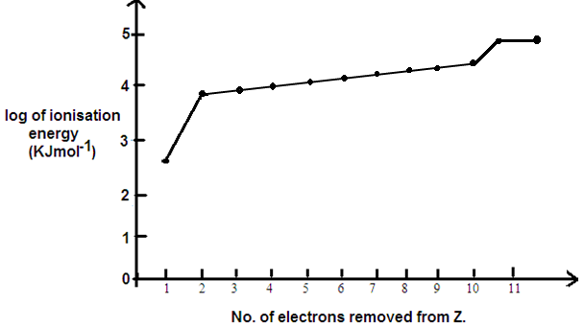

Explain the shape of the graph (2 ½ marks)

………………………………………………………………………………………………………………………………………………………………………………………………

………………………………………………………………………………………………………………………………………………………………………………………………

………………………………………………………………………………………………………………………………………………………………………………………………

………………………………………………………………………………………………………………………………………………………………………………………………

………………………………………………………………………………………………………………………………………………………………………………………………

………………………………………………………………………………………………………………………………………………………………………………………………

1. (a) (i) What is meant by the term **thermosetting plastic?**  (01 marks)

………………………………………………………………………………………………………………………………………………………………………………………………

………………………………………………………………………………………………………………………………………………………………………………………………

(ii) Name two thermosetting plastics (01 mark)

………………………………………………………………………………………………………………………………………………………………………………………………

(b) A polymer has the structure

OCH2CH2CO2CH2CH2CO

n

(i) Write the structure of the monomer (01 mark)

**…………………………………………………………………………………………………………………………………………………………………………………………………………**

**……………………………………………………………………………………………………**

(ii) State the type of polymerization reaction leading to the formation of polymer. (½ marks)

…………………………………………………………………………………………………………………………………………………………………………………………………………

(c) When 5 x 10 – 3 moles of this polymer was hydrolysed, 9**.**0g of monomer was obtained. Calculate value of n (2 marks)

…………………………………………………………………………………………………………………………………………………………………………………………………………

……………………………………………………………………………………………………

…………………………………………………………………………………………………………………………………………………………………………………………………………

……………………………………………………………………………………………………

…………………………………………………………………………………………………………………………………………………………………………………………………………

……………………………………………………………………………………………………

…………………………………………………………………………………………………………………………………………………………………………………………………………

1. (a) What’s meant by the term **ebullioscopic constant** (Kb)? (01 mark)

…………………………………………………………………………………………………………………………………………………………………………………………………………

……………………………………………………………………………………………………

……………………………………………………………………………………………………

(b) (i) 2**.**7g of ethanamide (CH3CONH2) was dissolved in 75g of ethanol . Calculate the boiling point of the resultant solution. (ebullioscopic constant, Kb of ethanol is 1**.**15oCmol – 1kg – 1 and the boiling point of ethanol is 78oC) (3marks)

…………………………………………………………………………………………………………………………………………………………………………………………………………

……………………………………………………………………………………………………

…………………………………………………………………………………………………………………………………………………………………………………………………………

……………………………………………………………………………………………………

…………………………………………………………………………………………………………………………………………………………………………………………………………

(ii) State any two assumptions made in the calculation in b (i) above. (01 mark)

…………………………………………………………………………………………………………………………………………………………………………………………………………

……………………………………………………………………………………………………

1. Complete the following organic reactions and give the systematic (IUPAC) names of the main organic product in each case

(i) (CH3)2 C = CH2 HCl

Name the product.

**…………………………………………………………………………………………………………………………………………………………………………………………………………**

(ii) HOCH3 + CH3CH2COOH Conc H2SO4

Warm

Name of product:

…………………………………………………………………………………………………………………………………………………………………………………………………………

(iii) n CH2 = CH ROOR

Heat, high pressure

Name of product:

…………………………………………………………………………………………………………………………………………………………………………………………………………

(iv) (CH3)3CCl NaOH(aq)

Heat

Name of product

…………………………………………………………………………………………………………………………………………………………………………………………………………

1. (a) State three characteristic properties of copper as a transition metal element.

(1½ mark)

…………………………………………………………………………………………………………………………………………………………………………………………………………

…………………………………………………………………………………………………………………………………………………………………………………………………………

……………………………………………………………………………………………………

(b) (i) Write the electronic configuration of copper.

…………………………………………………………………………………………………………………………………………………………………………………………………………

(ii) State the common oxidation states exhibited by copper in its compounds. (01 mark)

…………………………………………………………………………………………………………………………………………………………………………………………………………

1. State what is observed and in each case write equation of reaction that takes place when the solution containing Cu2+ ions was added to
2. 1cm3 of potassium hexacyanoferrate (II) solution ( 1 ½ marks)

Observation

………………………………………………………………………………………………………………………………………………………………………………………………………………………………………………………………………………………………………………

Equation

…………………………………………………………………………………………………………………………………………………………………………………………………………

……………………………………………………………………………………………………

(ii) Magnesium powder

Observation (1 ½ marks)

…………………………………………………………………………………………………………………………………………………………………………………………………………

……………………………………………………………………………………………………

Equation

…………………………………………………………………………………………………………………………………………………………………………………………………………

1. (a) What is meant by the term **eutectic mixture?**

…………………………………………………………………………………………………………………………………………………………………………………………………………

…………………………………………………………………………………………………………………………………………………………………………………………………………

(b) Figure 1.2 below shows the phase diagram for sodium chloride – water system

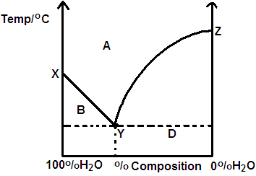

1. Name the point X, Y and Z (1 ½ marks)

X ……………………………………………………………………………………...

.Y ……………………………………………………………………………………..

Z ……………………...................................................................................................

(ii) Label phases A, B, C and D (2 marks)

A …………………………………………………………………………………….

B ……………………………………………………………………………………

C ……………………………………………………………………………………

D ………………………….......................................................................................

1. A cell was constructed as shown below

Pt(s)/Cr2+(aq),Cr3+(aq) // MnO4-(aq) , Mn2+(aq), H+(aq)/Pt(s)

(a)Write equations for the reactions that occur at the:

(i) Anode

…………………………………………………………………………………………………………………………………………………………………………………………………………

(ii) cathode

…………………………………………………………………………………………………………………………………………………………………………………………………………

(b) Using the equations in a(i) and a(ii), write the overall cell reaction. (1 ½ marks)

…………………………………………………………………………………………………………………………………………………………………………………………………………

(c) The electrode potentials for the systems Cr2+/Cr3+ and Mn2+/MnO4 – are – O**.**4O2 and + 1.52 volts respectively. Calculate the cell voltage. (01 ½ marks)

…………………………………………………………………………………………………………………………………………………………………………………………………………

……………………………………………………………………………………………………

**SECTION B:**

***Answer six questions from this section***

1. Complete the following organic reactions and write the accepted mechanisms.

(3 marks @)

1. 

…………………………………………………………………………………………………………………………………………………………………………………………………………

…………………………………………………………………………………………………………………………………………………………………………………………………………

…………………………………………………………………………………………………………………………………………………………………………………………………………

……………………………………………………………………………………………………

(b) (CH3)2CO Na2SO3(aq) (3marks)

H+(aq)

…………………………………………………………………………………………………………………………………………………………………………………………………………

…………………………………………………………………………………………………………………………………………………………………………………………………………………………………………………………………………………………………………………………………………………………………………………………………………………….

(c)  (3marks)

…………………………………………………………………………………………………………………………………………………………………………………………………………

…………………………………………………………………………………………………………………………………………………………………………………………………………

…………………………………………………………………………………………………………………………………………………………………………………………………………

1. (a) State factors that can affect melting points of elements or compounds. (2 marks)

…………………………………………………………………………………………………………………………………………………………………………………………………………

……………………………………………………………………………………………………

…………………………………………………………………………………………………………………………………………………………………………………………………………

……………………………………………………………………………………………………b) The melting points of elements in group IIA in the periodic table are given below

|  |  |  |  |  |  |  |
| --- | --- | --- | --- | --- | --- | --- |
| Element | Be | Mg | Ca | Sr | Ba | Ra |
| Mpt/oc | 1556 | 923 | 1123 | 1043 | 998 | 973 |

State the trend and explain the variation in trend of the melting points (05 marks)

…………………………………………………………………………………………………………………………………………………………………………………………………………

……………………………………………………………………………………………………

…………………………………………………………………………………………………………………………………………………………………………………………………………

……………………………………………………………………………………………………

…………………………………………………………………………………………………………………………………………………………………………………………………………

……………………………………………………………………………………………………

(c) Group (II) metals form few complexes. However, the tendency to form complexes decreases

down the group. Explain this observation (02 marks)

…………………………………………………………………………………………………………………………………………………………………………………………………………

……………………………………………………………………………………………………

…………………………………………………………………………………………………………………………………………………………………………………………………………

……………………………………………………………………………………………………

…………………………………………………………………………………………………………………………………………………………………………………………………………

……………………………………………………………………………………………………

1. State what is observed when the following substance are mixed and in each case illustrate your answer with an equation.

(a) Aluminium powder is added to an aqueous solution of iron (III) chloride**.** (03 Mark)

Observation:

………………………………………………………………………………………………………………………………………………………………………………………………………………………………………………………………………………………………………………

Equation:

…………………………………………………………………………………………………………………………………………………………………………………………………………

……………………………………………………………………………………………………

(b) 2-3 drops of 2,4-dinitrophenylhydrazine are added to a dilute solution of propanone.

Observation;

………………………………………………………………………………………………………………………………………………………………………………………………………………………………………………………………………………………………………………

Equation:

……………………………………………………………………………………………………

……………………………………………………………………………………………………

(c) Hydrogen sulphide gas is passed through a concentrated solution of nitric acid Observation;

………………………………………………………………………………………………………………………………………………………………………………………………………………………………………………………………………………………………………………

Equation:

……………………………………………………………………………………………………

……………………………………………………………………………………………………

13.(a) What is meant by the term **ligands** (01 Mark)

……………………………………………………………………………………………………………………………………………………………………………………………………………………………………………………………………………………………………………………………………………………………………………………………………………………

……………………………………………………………………………………………………

(b)Explain why transition metals commonly act as catalysts in chemical reactions.

…………………………………………………………………………………………………………………………………………………………………………………………………………

……………………………………………………………………………………………………

(c) In each case write equation of reaction catalysed by the following ions/species(1½marks @)

1. Vanadium pentoxide (V2O5) (1 ½ marks)

……………………………………………………………………………………………………

……………………………………………………………………………………………………

1. Iron (Fe) (1 ½ marks)

…………………………………………………………………………………………………………………………………………………………………………………………………………

1. Manganese (II) ions (Mn2+ ) (1 ½ marks)

…………………………………………………………………………………………………………………………………………………………………………………………………………

(d)Determine the Coordination number and Oxidation State of the central metal atom/ion in the following complexes. (2 Marks)

|  |  |  |
| --- | --- | --- |
| Complex | Coordination number | Oxidation state |
| Fe (CN)2-  6 |  |  |
| Cr (H2O)6Cl3 |  |  |

14.(a) State conditions under which the **partition law** is valid (1 ½ Marks)

…………………………………………………………………………………………………………………………………………………………………………………………………………

……………………………………………………………………………………………………………………………………………………………………………………………………………………………………………………………………………………………………………………………………………………………………………………………………………………

……………………………………………………………………………………………………

(b)An aqueous solution of 500cm3 of A containing 5.00g of A was extracted by 100cm3 of ether and two successive portions of 50.0cm3 of ether. (The partition Coefficient of A between ether and water is 90)

Calculate the mass of A extracted by

(i) 100cm3 of ether (2 ½ Marks)

…………………………………………………………………………………………………………………………………………………………………………………………………………

…………………………………………………………………………………………………………………………………………………………………………………………………………

(ii) Two successive portions of 50.0cm3 of ether (4 ½ Marks)

…………………………………………………………………………………………………………………………………………………………………………………………………………

…………………………………………………………………………………………………………………………………………………………………………………………………………

…………………………………………………………………………………………………………………………………………………………………………………………………………

…………………………………………………………………………………………………………………………………………………………………………………………………………

…………………………………………………………………………………………………………………………………………………………………………………………………………

…………………………………………………………………………………………………………………………………………………………………………………………………………

(c) Comment on the results in b(i) and b(ii) (01 Mark)

…………………………………………………………………………………………………………………………………………………………………………………………………………

……………………………………………………………………………………………………

……………………………………………………………………………………………………

# 15. Name the reagent that can be used to distinguish between the following organic compounds in each state what is observed if each compound is separated treated with the reagent.

O

(a) (CH3) 2C=O and CH3CH2 C-H (03 Marks)

Reagent(s)

……………………………………………………………………………………………………

……………………………………………………………………………………………………

Observations

…………………………………………………………………………………………………………………………………………………………………………………………………………

……………………………………………………………………………………………………

(b) (CH3)3COH and (CH3)2CHOH

Reagents

……………………………………………………………………………………………………

……………………………………………………………………………………………………

Observations

…………………………………………………………………………………………………………………………………………………………………………………………………………

……………………………………………………………………………………………………

1. HCOOH and HOOCCOOH

## Reagent

……………………………………………………………………………………………………

……………………………………………………………………………………………………

Observations

……………………………………………………………………………………………………

……………………………………………………………………………………………………

……………………………………………………………………………………………………

### 16. Hydrogen iodide decomposes when heated according to the equation

2HI (g) H2­(g) + I2(g) H= +11.3kjmol-1

(a)Write the expression for the equilibrium constant, KC for the reaction. (1mark)

…………………………………………………………………………………………………………………………………………………………………………………………………………

(b) 3.10g of hydrogen iodide was heated in 600cm3 bulb at 400 oC. When Equilibrium was attained the bulb was rapidly cooled to room temperature and broken under potassium iodide solution. The iodine formed from the decomposition required 13**.**40cm3 of 0.2M sodium thiosulphate solution for complete reaction.

(i)Why was the bulb rapidly cooled? (1 ½ Marks) …………………………………………………………………………………………………………………………………………………………………………………………………………

…………………………………………………………………………………………………

1. Calculate the value of the equilibrium constant (KC) at 400oC (05 Marks)

…………………………………………………………………………………………………………………………………………………………………………………………………………

…………………………………………………………………………………………………………………………………………………………………………………………………………

…………………………………………………………………………………………………………………………………………………………………………………………………………

…………………………………………………………………………………………………………………………………………………………………………………………………………

…………………………………………………………………………………………………………………………………………………………………………………………………………

……………………………………………………………………………………………………

(c)State what could happen to the value of KC when

1. Temperature is increased. ( ½ marks)

……………………………………………………………………………………………………

……………………………………………………………………………………………………

1. Neon gas is added. ( ½ marks)

……………………………………………………………………………………………………

……………………………………………………………………………………………………

1. Volume of buld is increased to 1000cm3. ( ½ marks)

……………………………………………………………………………………………………

……………………………………………………………………………………………………

17. Draw the structure and name the shape adopted by the following molecules.

|  |  |  |
| --- | --- | --- |
| Molecule | Structure | shape |
| BeC12 |  |  |
| H2 S |  |  |

(b) Explain why the molecules adopt the shapes you have stated in (a) above. (2 ½ Marks)

(i ) BeCl2

…………………………………………………………………………………………………………………………………………………………………………………………………………

………………………………………………………………………………………………………………………………………………………………………………………………………………………………………………………………………………………………………………

(ii) H2S (2 ½ Marks)

…………………………………………………………………………………………………………………………………………………………………………………………………………

………………………………………………………………………………………………………………………………………………………………………………………………………………………………………………………………………………………………………………

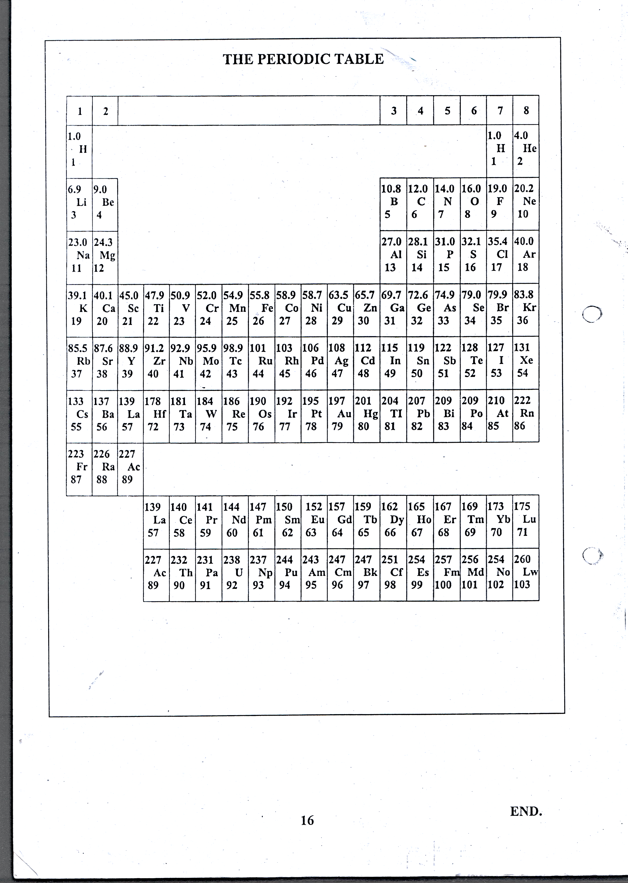

***END***